**Around the World** Scrapbook

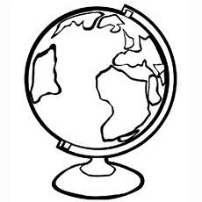

By: ________________

EGYPT

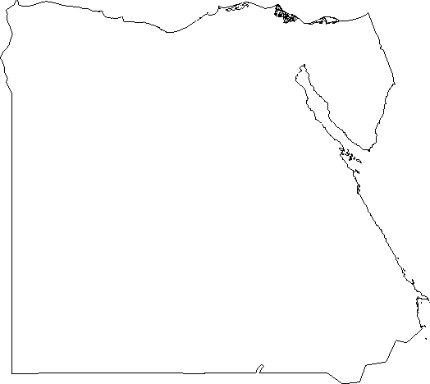

CANADA

