WINDOWS AND MIRRORS
s
Diversity in Our World
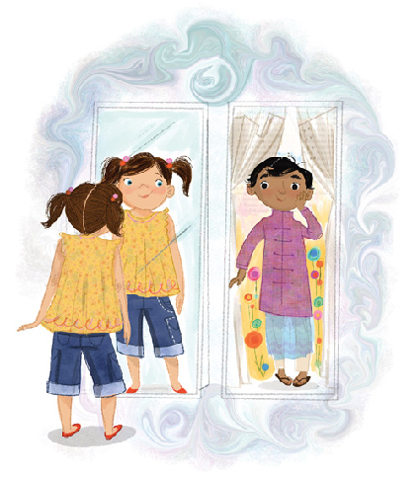
by Rohini Sharma and Andrea Dias
TABLE OF CONTENTS

Grade Level and Toolkit overview………………… 3

Arts-Based lesson Plan on Cultural Diversity …….. 4

Beautiful Stories…………………………………….5

Online Resources ………………………………..6-11

Culminating Activity ……………………………...12

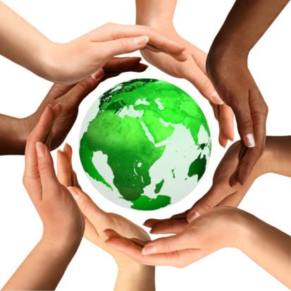

Grade 4 – Exploring Diversity in Our World

We have selected diversity as a topic to pursue within the Grade 4 curricular goal of “exploration.” Although this unit could touch upon many important issues, the lesson plan and culminating project included in this toolkit will explore cultural diversity and personal differences.
Our arts-based lesson plan will challenge pairs of students to research, explore, and be experts on a region, and then share their findings in a creative format with their peers. This will transition, through books, online resources, and other lessons, into a culminating activity involving exploring and embracing diversity and difference within oneself, and between people.

Curricular Links/Toolkit Objective:

The objective of the ‘Postcards’ lesson is to allow children to explore places around the world and to learn about other cultures. At the end, the final project ‘Labels’ will help children talk about discrimination and how we label different races with certain stereotypes. Hence, this toolkit will meet the following curriculum objectives:

4.1.1 Explore the concept of exploration
4.3.1 Examine major physical features of the world
4.3.3 Examine the relationship between humans and the physical environment

Arts-Based Lesson Plan – Postcards

Topic/Theme | Postcards From All Over The World Grade 4 Time: 45 minutes
Objectives | 4.1.1 Explore the concept of exploration  4.3.1 Examine major physical features of the world  4.3.3 Examine the relationship between humans and the physical environment
Materials | - The book, “Every Color” by Erin Eitter Kono  - Resource books on different countries, computers, ipads for pairwork.  - Blank Postcards  - Big map of the world spread on a bulletin board.
Introduction and Process | - Teacher reads the story ‘Every Colour’ to the class.  - After finishing the story, review each page closely, scanning for any recognizable landmarks. Ask and activate students’ prior knowledge of these landmarks, and write them on the board, along with their location.  - Teacher writes down any landmarks and regions that were unknown.  - Tell students that today they will be, in pairs, ‘visiting’ one of these regions and creating a postcard to send back to the class.  - They will visit these countries through resource textbooks scattered on the desks, ipads, and computers.  - Explain that they are to look for interesting information and places they would visit within the region they are researching (or visiting). Students should already have basic research skills.  - Explain that from the information they glean, they should draw and write a postcard, addressed to the class, about the place they visited! “Pick and choose a few things to write about, that you would do if you were visiting the country. Let’s brainstorm the kinds of things you could talk about.”  - For example (teacher models Taj Mahal):  - Dearest Grade 4,  - I have been thawing out in the 35 degree-Celsius heat in Agra, North India!  - Yesterday I visited the Taj Mahal. The Mughal emperor Shah Jahan had it built for his wife, whom he loved very much.  - Afterwards, we ate some gulab jamun, which are dough balls doused in sugar syrup.  - Love, Ms. Dias  - Teacher models drawing a Taj Mahal on the back of the postcard.  - Students go ‘visiting’ their landmark in pairs.
Conclusion | Teacher brings whole class back together to share what they wrote on their postcard. After one person in the pair reads it, the other person will stick the postcard on the corresponding part of the map of the world.
Extension/Enrichment | Multiple postcards, multiple regions, jigsaw activity where students share verbally about the place they are experts on.

Storybooks

As diverse learners, we want to read books that provide windows and mirrors into our society and ourselves. Mirrors that show us our own face, as strange and different as we might sometimes find it – it is comforting to find our face in a text. Windows that allow us to see faces, hear stories, reach people, in ways we may have never encountered before.

The Name Jar – Yangsook Choi
This story follows a Korean child, Unhei, who has just arrived in the USA with her family. She is worried about making friends and is scared that no one will be able to pronounce her name. Instead of introducing herself on her first day, she decides to ask her classmates to pick out a new name for her and write it in a jar. The story ends with one boy writing to encourage her to keep her Korean name. He later visits her house to get a Korean name for himself.
This is a wonderful story to teach about how welcoming diversity into one’s community and life can only enrich it.

Last Stop on Market Street – Matt de la Peña
This story tells of a boy named CJ and his nana who ride the bus together every Sunday. This week, CJ is not happy about it – he hates waiting in the rain, he hates being poor and not having a car like his friends. While riding the bus, his grandmother teaches him about the beauty of being in the world and interacting with its diversity – the bus driver who does magic tricks, the lady sitting with butterflies in a jar, the blind man with the dog, the musician, and the knitter. CJ changes his mind and is moved by it all. Finally, at the last stop on Market Street, they reach the soup kitchen: “sometimes when you’re surrounded by dirt, CJ, you’re a better witness for what’s beautiful.”
This story encourages students to appreciate the beauty in their own communities, and its diversity of personalities. It teaches to be kind.

ONLINE RESOURCES

- https://www.tolerance.org/
This website covers different types of diversity- race & ethnicity, religion, ability, class, immigration, gender and sexual identity, bullying and bias, rights and activism. This is a great resource for teachers as it incorporates- “Teaching Tolerance Lessons, Learning Plans, Perspectives Texts, Student Tasks, Teaching Strategies, Film Kits” and they are all based on the several aspects of diversity. The prepared plans will be instrumental but as well as there is a section where you can ‘Build a Learning Plan’ and basically as an educator, you can customize your lesson plan according to any social justice domain. One can choose any of the 4 domains of “Identity, Diversity, Justice and Action”, and then once the corresponding grade-level outcomes are chosen, one can select the theme and write or select an essential question that will guide the learning. Then once the topic is selected, a list of texts that meet the criteria will appear and as well as “students tasks (performance assessments) and teaching strategies (step-by-step classroom activities)” can be customized. As well as, there is a professional development section with subsections: “School Climate, Instruction, Classroom Culture, Family & Community Engagement, Teacher Leadership, Webinars”, containing articles, tips and suggested classroom activities centering ‘teaching tolerance’.

- https://diversebooks.org/
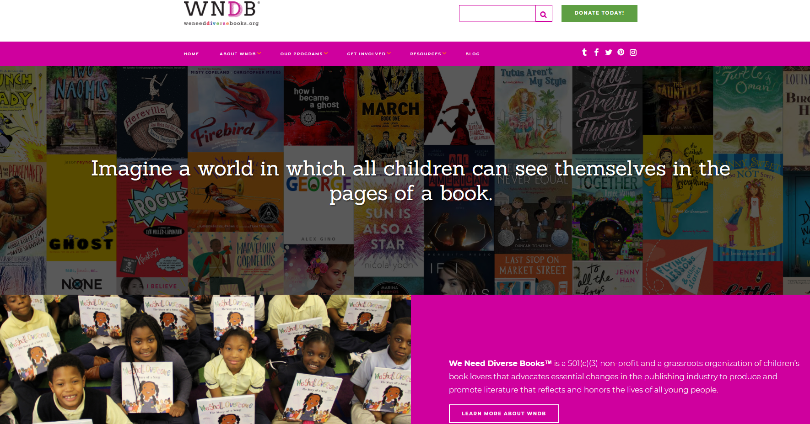
WNDB (We Need Diverse Books) is a grassroots organization which aims to help produce and promote literature “that reflects and honors the lives of all young people”. It includes a section where they have compiled a list of sites offering diverse literature for each topic- ethnicity, LGBTQ+, multicultural, social justice, disability. As well as, there are list of sties which take you to award winning books from various parts of the world- Middle East, American Indian, African, Asia/Pacific and sites such as the ‘South Asia Book Award (SABA)’ site contains K-12 lesson plans to help incorporate SABA books into the classroom. WNDB also has a “booktalk” section where they have created a kit which contains “lesser-known” diverse books, in which all children can see themselves in the pages of a book and provides tools to help “teachers, librarians and booksellers to “booktalk” these books to their students, patrons, and customers”. This kit not only lists the books, but it draws readers in by “providing them with comparative book and film titles” and targets books at specific kids with “perfect for…” suggestions. This site also contains information regarding an “OurStory” app, where the “free version will help all users find the perfect book and access cool content from authors. The paid version, called OurStory Pro, is a great tool for teachers, librarians and educators to access WNDB-themed curriculum and content”.

- http://www.cisv.org/resources/running-or-taking-part-in-educational-programmes/ed-activities/education-content-areas/diversity/
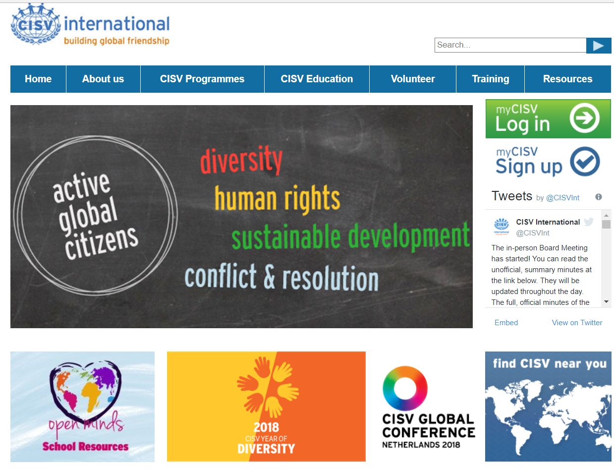
CISV International is a “global organization dedicated to educating and inspiring for peace through building inter-cultural friendship, cooperation and understanding”. This website contains a section with many education activities for various age groups, in each of these content areas- Diversity, Human Rights, Conflict and Resolution and Sustainable Development. The activities are not only listed but they are in the form of mini lessons containing descriptions, step by step instructions, education goals and materials required for the activities. There is an ‘Open minds’ section where, it features various short films by CISV’s partner organization momondo and it can be shown in the classroom to introduce diversity. One of the films ‘Dear mom and dad’ shows the experiences of children who were part of a CISV summer camp, where 48 children from 12 countries lived together for a month in a village, Sao Paulo, Brazil. These children had the opportunity to learn from each other and their messages were powerful such as ‘we are all different from outside but in the end, we are humans’. As well as, the ‘DNA journey’ consists of many stories of people who tested their DNA and the videos show how we can look/think we are different, but we are biologically connected to people from different parts of the world because of our ancestors. In this section of the CISV site, there are also two amazing kits titled- "Equally Different and Our Colourful World, which teach how easy it is to apply (and remove) labels and stereotypes and Open Minds”. The kits include activity sheets, teaching guides, and supplementary short films that illustrate the importance of “open-mindedness”.

- http://blogs.edweek.org/edweek/global_learning/2017/09/5_steps_to_build_a_diverse_classroom_library_and_encourage_empathy.html

This is a blog by Jennifer Williams, who is a literacy specialist, professor and member of the board of directors for the International Literacy Association. She discusses the importance of encouraging empathy for others in the classrooms and this can be done by expanding classroom libraries and that “there is not a single story, but that there is power and beauty in sharing many stories”. Jennifer provides a list of 30 books (Pre-Kindergarten through Grade 12) to help build a diverse classroom library. She also explains 5 steps to create a diverse classroom. Step 1- discuss the importance of diverse literature with the students. Step 2 is about surveying the students about their preferences in the classroom library [with prompts such as- What challenges does our community face that should be reflected in our classroom library? ("community" can be considered from any level: self, class, school, family, town, country, or world)]. Step 3 is to take an inventory of the current books with the children and depending on the classroom needs, add or remove books together. Step 4 is to let students research the types of diverse literature and then have ‘book talks’ about their favourite books. Finally, step 5 provides links to funding platforms such as DonorsChoose, GoFundMe and FirstBook, which help connect classrooms to donors who want to help schools. The ‘FirstBook’ organization also provides “free resources and reduced-priced books with multi-cultural titles, a library of global stories, and selections focused on social-emotional learning”.
Mohsin Hamid- “Empathy is about finding echoes of another person in yourself”.

- https://canlitsocialjustice.wordpress.com/picture-books/
This website is “an annotated bibliography of resources from a Canada-wide SSHRC-funded study on Canadian literature to promote social justice in the classroom.” There are various kinds of text such as novels, short stories, poetry and plays, nonfiction and picture books and under each type of text, there are 3 age groups- ‘Elementary, Junior High/Secondary and Secondary’ listed. The texts explore several aspects of social justice such as discrimination, colonialism, immigration, poverty, disabilities, resilience, death, war, Multiculturalism, LGBTQ, refugees, domestic violence and Indigenous people. This website not only provides a list of texts but along with the titles, the theme and brief summary of each text is also mentioned, and this helps readers or educators select their preferred text. Topics such as residential schools and Indigenous people are often not talked about in classrooms, as they are perceived to be difficult topics to teach young learners. However, this website explores these topics through picture books such as ‘Orphans in the sky’ by Bushey, J., which is about “Inuit legends”; Shin-chi’s canoe by Campbell, N. I., is about “Indigenous knowledge; Residential schools; Resilience”; Flour sack friends by Delaronde, D. L., is about “Community; Cooperation; Metis” and many more. Diverse literature provides an opportunity for teachers to discuss and promote social justice in the classrooms, with various age groups and this helps diminish “the fear of the unknown”, creating a positive and accepting classroom culture.

- http://publiclibrariesonline.org/2017/01/feature-mirrors-and-windows-diversity-in-childrens-picture-books/
Angela Bronson writes an article about “picture book diversity”, where the picture books need to be “windows and mirrors” for children. She got interested in picture books after discovering that the first picture book to feature an African American character, The Snow Day by Ezra Jack Keats, was not published until 1962.” This article makes references to other websites containing multicultural resources. For example, it refers to the Cooperative Children’s Book Center School of Education (CCBC), where there are links to various databases containing books from different parts of the world, one of them is “Africa Access Review, which is a searchable database offering critical reviews of over 900 titles on Africa.” Another link takes one to the Children's Book Council (CBC) diversity, where there is a resources section for teachers and librarians, containing lesson plans, discussion guides, book lists, articles, blogs and award-winning literature, all based on diversity.

The following two TED TALKS can help educators understand the concept of literature being ‘windows and mirrors’ for children and the importance of diverse literature.

- ‘The Windows and Mirrors of Your Child's Bookshelf’ by Grace Lin

“Grace is an author and illustrator of books for children and teens. She shows how the books that are not on your child's bookshelf are just as important as those that are. Grace's books typically focus on the Asian-American experience. She believes, "Books erase bias, they make the uncommon every day, and the mundane exotic. A book makes all cultures universal."
https://youtu.be/_wQ8wiV3FVo

- ‘A danger of a single story’ by Chimamanda Adichie

“Novelist Chimamanda Adichie tells the story of how she found her authentic cultural voice -- and warns that if we hear only a single story about another person or country, we risk a critical misunderstanding”
https://www.ted.com/talks/chimamanda_adichie_the_danger_of_a_single_story?utm_source=tedcomshare&utm_medium=referral&utm_campaign=tedspread-a

FINAL PROJECT- ‘LABELS’
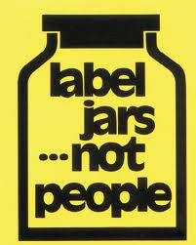
The aim of this final project is to start a discussion about labelling- how we all do it, how it makes us feel and how it can easily be damaging to us and people around us. In the beginning, the teacher can explain what a label is with a simple definition: labelling is describing someone or something in a word or short phrase e.g. ‘Jack is always lazy’, or ‘Anne is never happy’. The teacher assigns labels to each child for example careful, leader, talkative, sensitive, joker, brainy, hyper, sporty, creative (on different coloured sheets). Then these labels will be placed either at the back of the child or on the forehead (possibly with a headband), but the student cannot see their own labels and they cannot tell the other students about what’s on their label. Instead, they need to treat their classmates according to their labels. The teacher gives the students a ‘Dream vacation’ task, where they could discuss questions such as ‘Where are you going, How will you get there?, What will you see and do?, Where will you stay?, How long will you stay?’ and other questions students would like to ask. They can pick places from the postcards pinned on the world map (from the arts based lesson plan on page 4). This task is given to each child so that they have something set to discuss and while they are performing this task they are treating each other according to the displayed labels. At the end of the 20-30 minutes mark, the teacher removes the labels and then for around 15 minutes they need to write in the provided journals about their experience. Prompts such as: How did you feel during the activity (including both times, where you are being treated according to the label and when you are treating the other student according to the label), Was it hard to treat people as the label stated?, could be answered but also students can express their emotions through art. This project will span over 3-4 weeks during the social studies classes and students will be asked to film at least two perspectives, where the student’s own reaction/perspective of being treated by their own label is captured [mirrors] and they will also capture their classmate’s reaction/perspective of being treated with their label [windows].
At the end of this project, the journals, films and/or art representations of the activity will be shared with the class. Teacher will guide the class discussion with questions such as- Did it make them feel as if they were put in a box? Did they feel as if they couldn’t be themselves? Did anyone start acting like his or her label? Can you think of any time you were labelled in real life? What labels do we put on other people and ourselves in real life? Why do you think it’s so easy for people to label each other? Do you think it’s easy for people to break out of their label and start being themselves? How do you think labels affects them? And us? These questions can help talk about discrimination and stereotypes related to different races and how we label certain races with those stereotypes.

The project was inspired by one of the ‘Open Mind’ activities, ‘Equally Different’, listed in this website- http://www.cisv.org/mycisv/about-us/our-partners/cisv-and-momondo/. There is also a video which shows children from CISV summer camp who carried out this ‘label’ activity (https://youtu.be/E0yV59ZMqu8).

In the end of the project, the video ‘I am NOT Black, you are NOT White’ (https://youtu.be/q0qD2K2RWkc) can be watched as a class. It ties in well with the project, as it shows the concept of labels in the real life. The video shows how we label each other according to the colour of our skin and how these labels are meant “to divide us.”

