You and Your World Kindergarten Toolkit

Healthy Lifestyles

Mackenzie Albert, Colleen Daly, Rachel Prosser, Megan Watt
You and Your World

Grade Level: Kindergarten

Topic/Theme: Healthy Lifestyles

Objective: To promote, encourage, and explore healthy lifestyle activities.

Curricular Outcome:
- K 2.1 describe the importance of personal hygiene and practice it in order to reduce the spread of germs and diseases
- K 2.2 identify and explain types of activities that support a healthy lifestyle.

Table of Contents

Arts-based lesson plan…………….………………………………………………………….3

Brief summaries of story books……………………….……………………………………...5

Online resources………………………………………………….……………………………8

Culminating activity….……….……………………………………………………………..11

Arts-based Lesson plan

Grade: Kindergarten
Lesson: Benefits of healthy lifestyles through art.
Total Time: Approximately 35 minutes

Curricular Outcome:
- K 2.2 identify and explain types of activities that support a healthy lifestyle.

Intro: Model a poster of a healthy activity (i.e. hiking with family). Discuss with students that this is a healthy activity. Discuss the idea of healthy activities, why they are considered healthy, and why they are important. Ask the students to think about what they do that is a healthy activity. There will be a short discussion to answer these questions. Have students talk to their elbow partner about what they like to do that is active and fun.
Time: 8-10 minutes

Middle: Have students go to their centers, and get them to come up with ideas of what to do at recess that is active. For example, playing soccer, playing tag, etc. Students will be provided with water paint, pencil crayons, crayons, and markers. They will be instructed to create a poster that represents what they do at recess that is considered a healthy lifestyle activity.
Time: 20 minutes

Closure: Have students meet back on the reading mat. Ask students what they learned about healthy activities. Students will have the opportunity to share their learnings and posters.
Time: 5-7 minutes

Differentiation: To differentiate this activity, students will have the option of using different tools (i.e. markers, crayons, etc.) to create their posters.

Materials:
Blank paper. Paint, cups of water, paint brushes, pencil crayons, markers, crayons, pencils, worksheet (see below)

What Will You do at Recess?

Storybooks

Good Morning Yoga: a pose-by-pose wake up story
By: Mariam Gates
Illustrated by: Sarah Jane Hinder

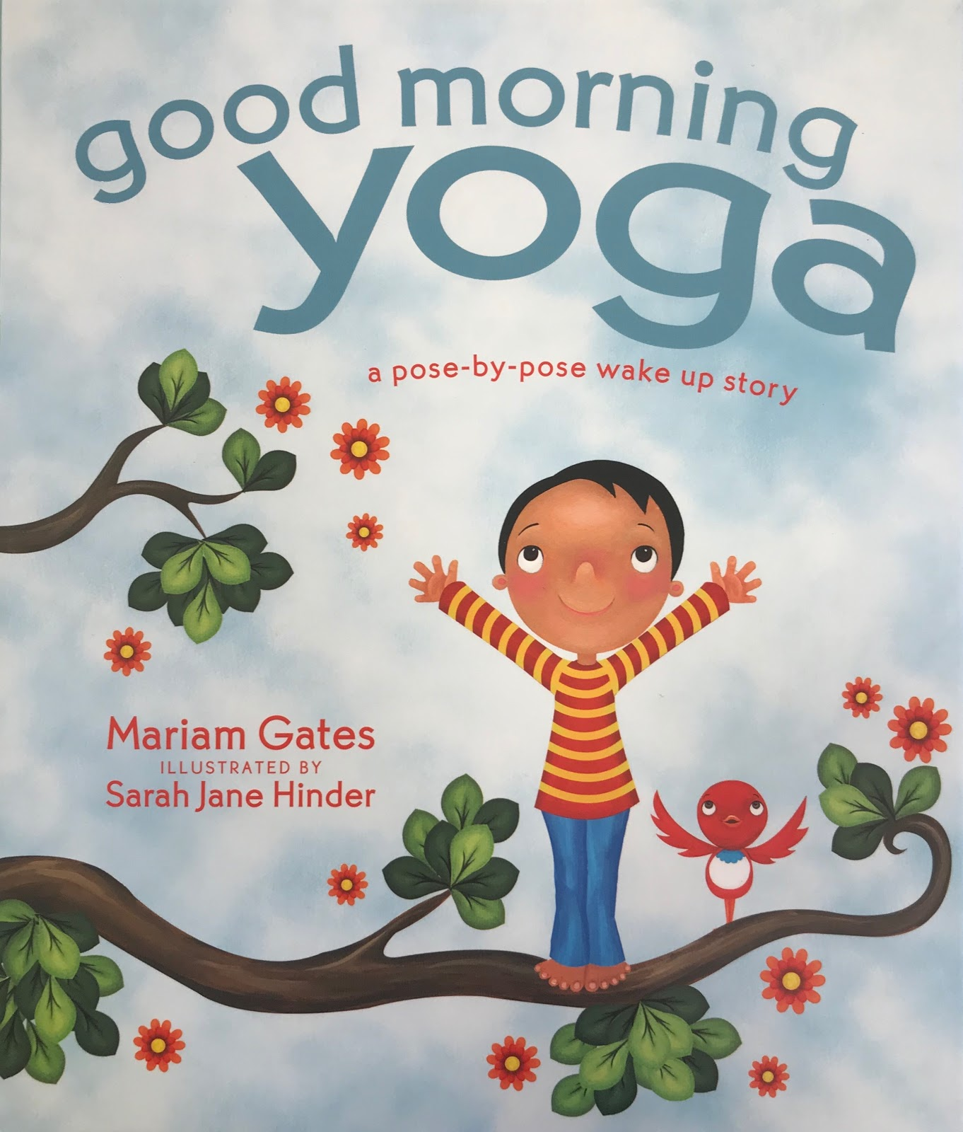

This story walks children through yoga poses by relating the movements to other outdoor activities. The story follows a repetitive pattern on each page that is used to remind children about meditative breathing while they are moving through the movements. “As I breathe in, as I breathe out, I bend my knees and sweep my arms back. A brave ski jumper ready to fly, a lightning bolt flashing across the sky. As I breathe in, as I breathe out, with my knees bent, I glide my hands up high.” At the end of the story there is a page with many more yoga poses and little explanations on how to do them.

Outcome:
- K 2.2 identify and explain types of activities that support a healthy lifestyle

Pete the Cat: Go, Pete, Go!
By: James Dean

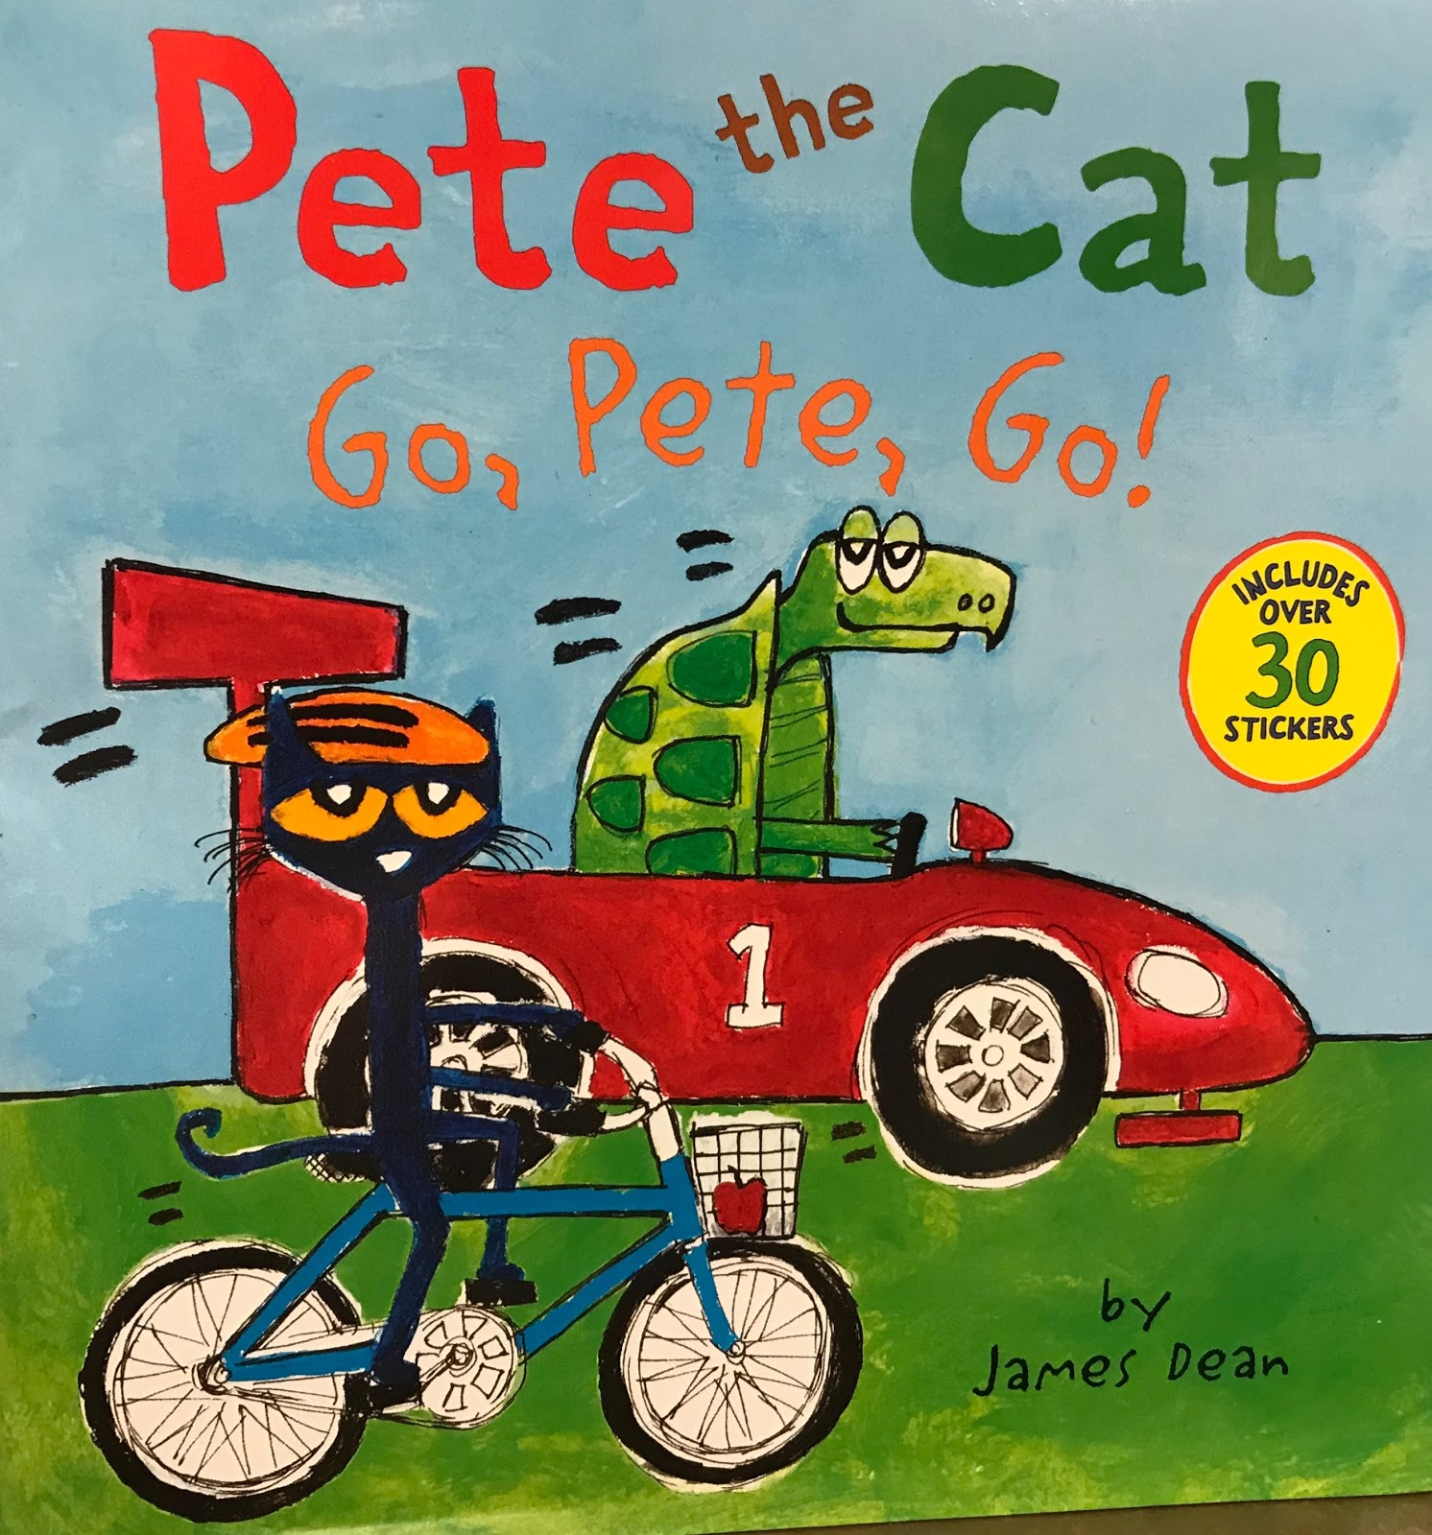

This story is about Pete and his friend having a race and is similar to the story about the tortoise and the hare. Pete is on a bike and his friend is in a car and they begin to race. With many stops and goes along the way, Pete always seems to be making healthier choices, while his friend is not. Although it seems obvious that his friend will win in the car, Pete never gives up and enjoys his bike ride. In the end Pete wins the race and briefly mentions the benefits of being active, which could be expanded greatly in discussion.

Outcome:
- K 2.2 identify and explain types of activities that support a healthy lifestyle

The Berenstain Bears: And Too Much Junk Food
By: Stan & Jan Berenstain

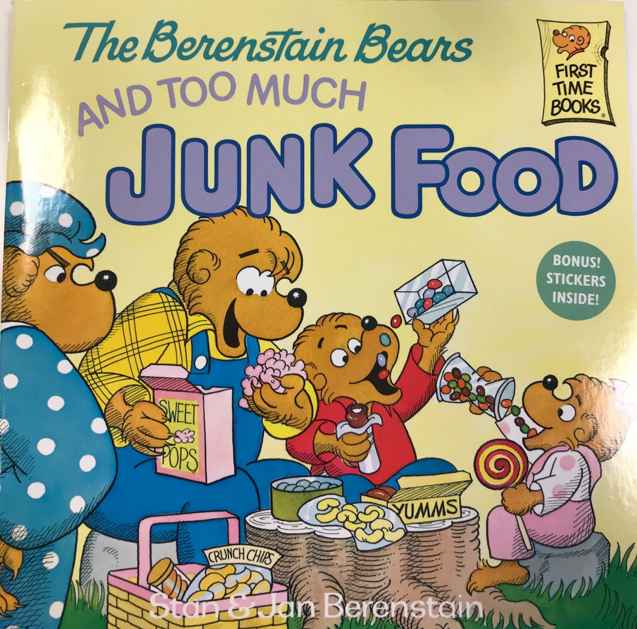

This is a story from a series called, The Berenstain Bears, where Mama bear discovers that her two bear cubs are eating too much junk food. Mama bear decides to take the family to the grocery store where they will load up on lots of healthy foods to eat. At the store the Berenstain family runs in to their family doctor, and Mama bear explains that the cubs have been eating too much junk food. The Doctor Grizzly offers for the cubs to come over to her office and look at X-rays of themselves to learn more about eating well and getting exercise. The cub leaving feeling motivated to change their bad habits, and at the end of the story the family is back in shape again and running a race together.

Outcome:
- K 2.2 identify and explain types of activities that support a healthy lifestyle

Online Resources

“Germ Smart – Wash Your Hands!”
Former Saskatoon Health Region
Published: August 19, 2013
Retrieved from: https://www.youtube.com/watch?v=NoxdS4eXy18

This video outlines the importance of washing your hands. In the beginning, it shows a young boy sneeze and not cover his hands. A “germ” comes flying and lands on the counter and he and another germ begin to discuss how they will spread by people not washing their hands and how they will make other people sick. Just then, the little boy’s mother comes around and teaches the boy the importance of sneezing and/or coughing into your elbow rather than your hand and how it’s important to wash your hands frequently.

This could be used in the social studies classroom to teach children how germs spread and how it is important to wash our hands often.

Outcome:
- K 2.1 describe the importance of personal hygiene and practice it in order to reduce the spread of germs and diseases

Nestlé Healthy Active Kids
Retrieved from: https://www.healthyactivekids.com.au/families/online-video/

This website offers multiple different videos that explain healthy lifestyles. The videos outline healthy lifestyle habits that fuel your body, such as exercising, healthy eating, and drinking water. They use the example that your body needs fuel just like a car in order to work. They explain why these habits are good for your body and are necessary for your body to move.

This resource could be used in a social studies classroom to further educate students about the important of living a healthy lifestyle.

Outcome:
- K 2.2 identify and explain types of activities that support a healthy lifestyle.

Healthy Kids; Eat Well, Get Active
Retrieved from: https://www.healthykids.nsw.gov.au/

This website has many different sections to use as a teacher. However, it is not really a resource to use with the kids, rather a resource to use to help to create the lesson plan. There are sections on sports, games and food. There are different tabs for “Kids & Teens” and “Parents & Carers”. There are experiments that you can do with the kids help them learn about things such as why you should not eat salty foods too often. This would be an excellent resource to help individuals learn more about being healthy. The information provided on this website would be great to use in a classroom.

Outcome:
- K 2.2 identify and explain types of activities that support a healthy lifestyle.

Nourish Interactive
Retrieved from: http://www.nourishinteractive.com/

This website informs the public about the importance of nutrition. Focusing on nutrition, this website encourages people to eat healthy. They provide a multitude of resources for children, adults, and educators. For example, this site has games and printables that an educator can bring into their classroom to teach students all about nutrition and healthy eating. Some examples of the printables available are pages with activities of sorting food into different categories. Furthermore, there is an “adult section” that provides nutrition tips. These tips can be used to promote proper nutrition in the classroom.

Outcomes:
- K 2.1 describe the importance of personal hygiene and practice it in order to reduce the spread of germs and diseases
- K 2.2 identify and explain types of activities that support a healthy lifestyle.

Heart and Stroke Foundation
Retrieved from: http://www.heart.org/HEARTORG/HealthyLiving/HealthyKids/HowtoMakeaHealthyHome/Top-10-Tips-to-Help-Children-Develop-Healthy-Habits_UCM_303805_Article.jsp#.WpiE4hPwZQJ

This is a great resource for teachers to read even though it is directed at parents. It provides the top ten tips to help children live a healthy lifestyle. They list things such as being positive, make it a family goal, limit screen time, promote healthy eating and physical activity. However, one of the most important tips this website offers for educators is “be a good role model.” As educators, it is our responsibility to set good examples and be positive role models for our students. For example, if a teacher is eating a healthy meal for lunch and healthy snacks, drinking water and doing lots of physical activity in the classroom and in the schoolyard, they are modelling healthy lifestyle activities for their students.

Outcome:
- K 2.2 identify and explain types of activities that support a healthy lifestyle.

Good Habits for Life
Retrieved from: https://goodhabitsforlife.act.gov.au/kids-at-play/active-play-games-and-activities

This website has much to offer! Even though it is based on children ages 0-5, it is a great resource that provides the public with information about topics such as active play, screen time, drinking water, and proper nutrition. Under the section “active play” they explain the benefits of active play in children and recommend that a child gets 3 hours of physical activity each day. This tab offers a lot of information about “active play”. Under the section “screen time”, this resource looks at the appropriate amount of time children should have screen time and they offer ideas how to switch from screen time to play. This website provides ample amounts of information that an educator can take into their classroom to promote active play in their classroom.

Outcome:
- K 2.2 identify and explain types of activities that support a healthy lifestyle.

Culminating Project

In order to demonstrate what the students have learned about Healthy Lifestyles throughout this unit, they are going to create a classroom book that illustrate the many activities that promote healthy lifestyles. These activities can include, but are not limited to, physical activity, healthy eating, sleeping, brushing your teeth, taking a shower, etc.
Each student will receive one piece of paper and writing materials will be provided (pencils, pens, markers, crayons, paint, etc.). Each student will be responsible for creating one page that will be a part of the entire book. They will need to represent what they learned either by drawing or writing a healthy lifestyle activity of their choice.

Once all the student’s individual pages are complete, they will all be bound into a book that will represent numerous ways to live a healthy lifestyle. The book will be placed in the classroom library for all students to view at their leisure.

